**Coding Assignment 3**

***Shubham Maheshwari(17EC10055)***

**TASK A)**

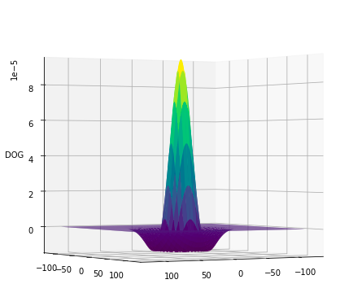

The above plot shows the spatial domain of representation of Difference of Gaussian (DoG) with 𝜎1 =18 and 𝜎2=20 and filter width = 12*sigma2 varying from -6𝜎 to 6𝜎. It acts as a bandpass filter by allowing only the region around the mean to pass through and by variation of the sigmas a narrower or a wider BPF can be obtained.

**Task B)**

**Case 1 - 𝜎1 ≪ 𝜎2; 𝜎1 is small, about a few pixel widths: {𝜎1 = 2, 𝜎2 = 20}**

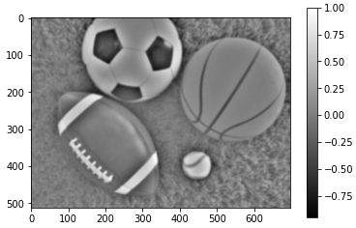

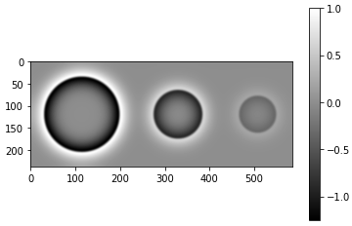

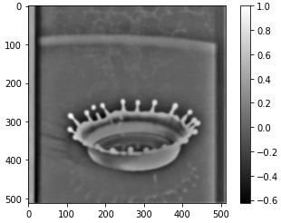

**Case 2 - 𝜎1 ≈ 𝜎2; 𝜎1 is large, about many pixel widths:{𝜎1 = 18, 𝜎2 = 20}**

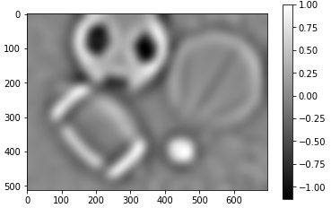

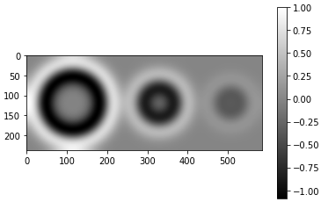

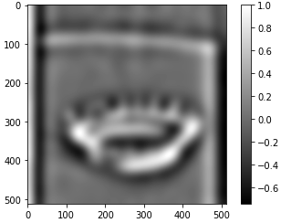

**Case 3 - 𝜎1 ≈ 𝜎2; 𝜎1 is small, about a few pixel widths: {𝜎1 = 3, 𝜎2 = 4}**

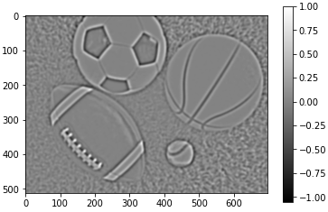

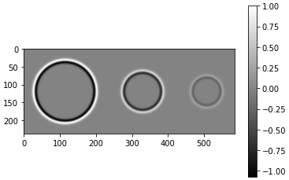

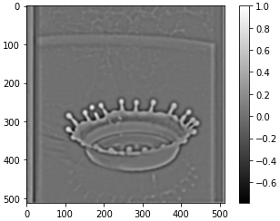

**Comments:**

* ***BLOB Detection:*** In the case of blob detection, we get the best results when both sigmas are high about many pixel widths. A greater value of sigma gets better results for blob detection which basically involves looking for a local extrema but at a computational expense.
* ***EDGE Detection:*** Edge detection works best when both sigmas are about a few pixel widths and have a value close to each other. When we increase the sigma, we are blurring the image more and then the thin edges don’t get detected. Here an edge is represented by a thin black line that is visible between 2 white lines for each edge denoting the change from maxima to minima and back to maxima. The convolution between the subtraction of gaussian kernels and the input image results in the edge detection of this image.
* ***EDGE Localization***: Similar to the case of Edge detection, here also having both sigmas about a few pixel widths a value close to each other works best. It gives the worst results if we keep the sigma values high as seen in the above output plots for case 2 because high sigmas cause gaussian smoothing whereas low sigmas are responsible for low variance and result in better hit rate for edges.